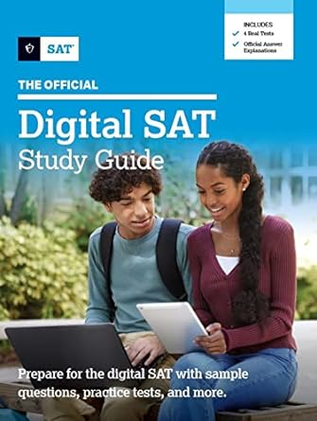 **₦**49,500

**The Official Digital SAT Study Guide (Official Digital Study Guide)**

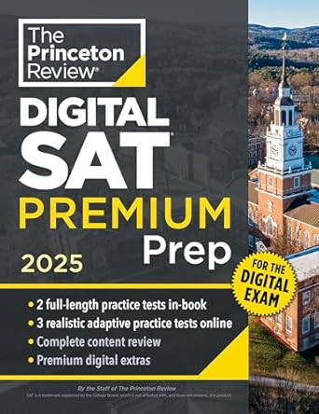 **₦**74,000

# Princeton Review Digital SAT Premium Prep, 2025: 5 Full-Length Practice Tests (2 in Book + 3 Adaptive Tests Online) + Online Flashcards + Review & Tools (2025) (College Test Preparation)

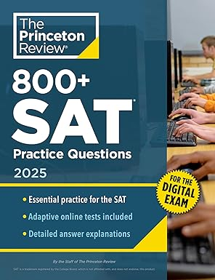 **₦**59,000

# 800+ SAT Practice Questions, 2025: In-Book + Online Practice Tests for the Digital SAT (2025) (College Test Preparation)

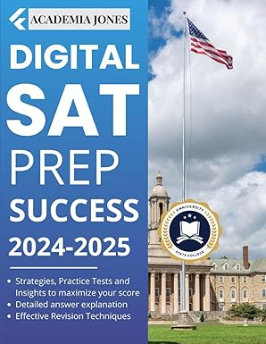 **₦**63,700

**Digital SAT PREP Success 2024: Strategies, Practice Tests and Insights to maximize your score: 3 full length Practice Tests + detailed explanations**

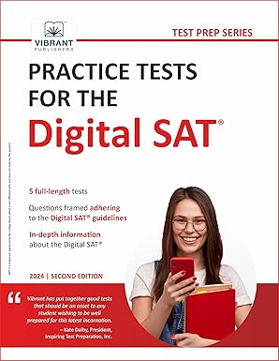 **₦**68,000

# Practice Tests for the Digital SAT